Ideation Phase
Define the Problem Statements
Date | 31 January 2025
Team ID | SWTID-2026-3677
Project Name | Auto Ticket Classification using Flow Designer
Maximum Marks | 2 Marks
Customer Problem Statement Template:
Create a problem statement to understand your customer's point of view. The Customer Problem Statement template helps you focus on what matters to create experiences people will love.
A well-articulated customer problem statement allows you and your team to find the ideal solution for the challenges your customers face. Throughout the process, you’ll also be able to empathize with your customers, which helps you better understand how they perceive your product or service.
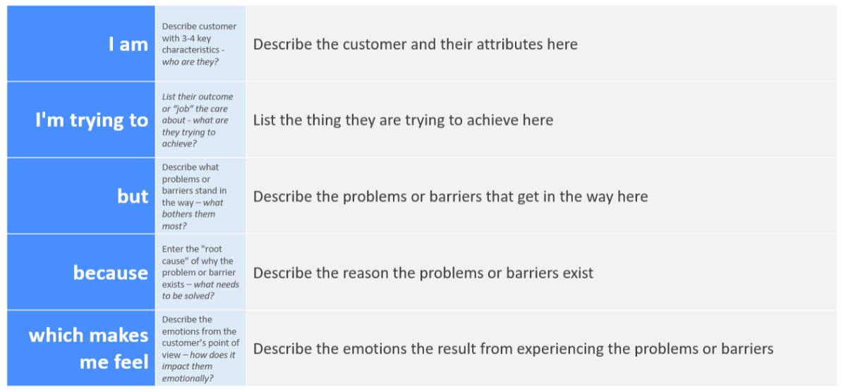
Reference: https://miro.com/templates/customer-problem-statement/
Example:
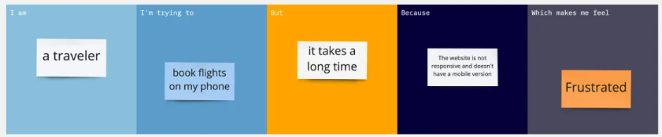
Problem Statement (PS) | I am (Customer) | I’m trying to | But | Because | Which makes me feel
PS-1 | Service desk agent in ServiceNow | Assign incoming incidents to the right support group | Tickets are assigned manually and sometimes go to the wrong group | No Flow Designer flow reads the category and short description | Overwhelmed
PS-2 | Employee who raises an incident | Get my issue resolved quickly | My ticket waits in the wrong queue | It is not classified automatically when it is created | Frustrated

